

**Placement Empowerment Program**

***Cloud Computing and DevOps Centre***

***Secure Access with a Bastion Host: Set up a bastion host in a public subnet to securely access instances in a private subnet.***

**Name: VIJAYA NANDANA M Department: CSE**

**Introduction**

In cloud environments, securing access to private instances is crucial. A Bastion Host (or Jump Box) is a special-purpose instance that acts as a secure gateway to access EC2 instances in a private subnet. Instead of exposing private instances directly to the internet, users connect to the Bastion Host first and then access the private instances from there.

This setup enhances security by limiting direct SSH access to private instances and applying strict security controls**.**

**Objectives**

1. Create a VPC with a Public and Private Subnet.
2. Set Up a Bastion Host in the Public Subnet.
3. Launch a Private EC2 Instance in the Private Subnet.
4. Configure Secure SSH Access via the Bastion Host.
5. Enhance Security by restricting SSH access and considering AWS Systems Manager as an alternative.

**Step by Step Overview**

**1. Create a VPC with Public and Private Subnets**

**1.1 Create a VPC**

* Go to AWS Console → VPC Dashboard.
* Click Create VPC and name it MyVPC.
* Set IPv4 CIDR Block: 10.0.0.0/16.
* Click Create VPC.

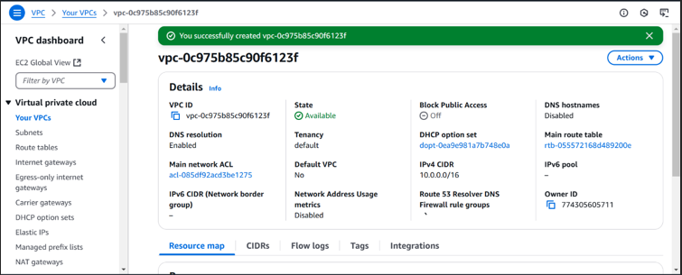

**1.2 Create a Public Subnet**

* Go to Subnets → Create Subnet.
* Select MyVPC and set CIDR block 10.0.1.0/24.
* Enable Auto-Assign Public IP.

**1.3 Create a Private Subnet**

* Repeat the same process, but use CIDR block 10.0.2.0/24.
* Do not enable Auto-Assign Public IP.

**2. Configuring Public Subnet for Internet Access**

**Create an Internet Gateway (IGW)**

* Go to Internet Gateways → Click Create Internet Gateway.
* Name it MyIGW, attach it to MyVPC.

**Update Public Route Table**

* Go to Route Tables → Create Route Table → Name it PublicRouteTable.
* Associate it with PublicSubnet.
* Add a route:
  + Destination: 0.0.0.0/0
  + Target: Internet Gateway (MyIGW)

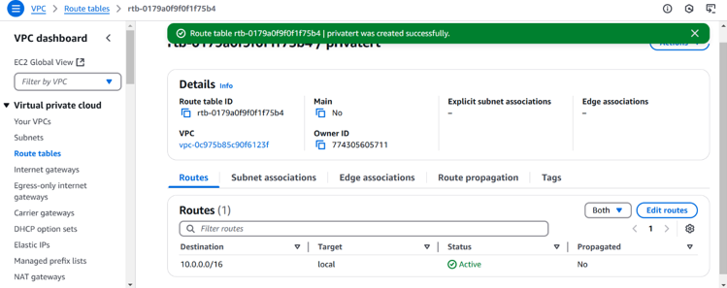

**3. Launch a Bastion Host (Public Subnet)**

- Go to EC2 Dashboard → Launch Instance.

- Select Amazon Linux 2 (or Ubuntu).

- Choose t2.micro (Free Tier Eligible).

- Place it in PublicSubnet with Auto-Assign Public IP enabled.

- Create a Security Group (BastionSG):

* + Allow SSH (Port 22) from Your IP (xx.xx.xx.xx/32).
* Create or use an existing key pair (e.g., bastion-key.pem).

Click Launch.

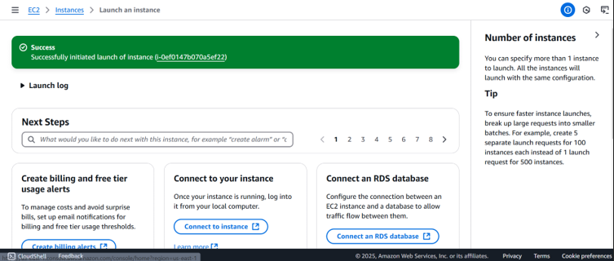

**4. Launch a Private EC2 Instance**

- Create a EC2 instance and create a Security Group.

- Allow **SSH (Port 22) only from Bastion Host’s Security Group**.

-Use the same **key pair** (bastion-key.pem).

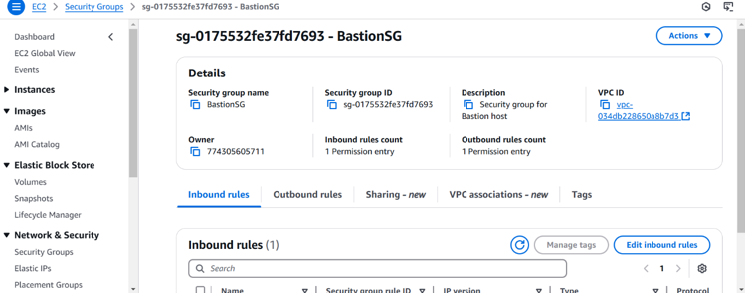

**5. Connect to the Private Instance Using the Bastion Host**

**-** Connect to the Private Instance Using the Bastion Host

***ssh -i bastion-key.pem ec2-user@<bastion-public-ip>***

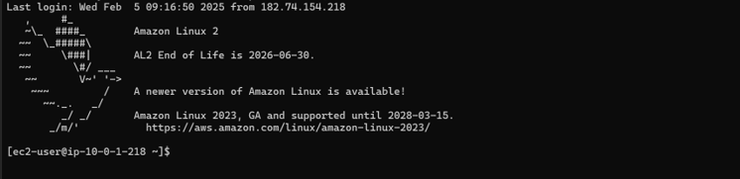

**SSH from Bastion to Private Instance**

1. Copy the bastion-key.pem file to the Bastion Host:

scp -i bastion-key.pem bastion-key.pem ec2-user@<bastion-public-ip>:~/

1. Connect to the Bastion Host:

ssh -i bastion-key.pem ec2-user@<bastion-public-ip>

1. Change permissions for the key file:

chmod 400 bastion-key.pem

1. SSH into the Private Instance from the Bastion Host:

ssh -i bastion-key.pem ec2-user@<private-instance-ip>

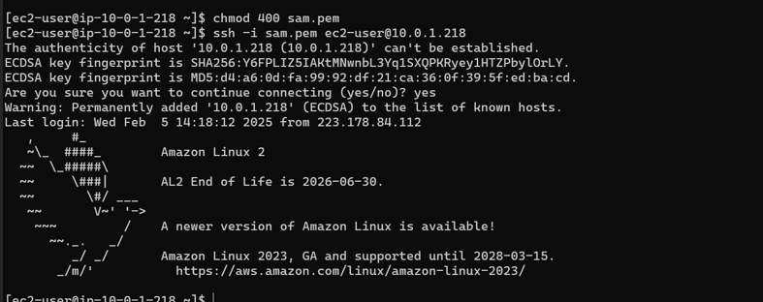

**6. Step 6: Secure Your Bastion Host**

**6.1 Restrict SSH Access**

* Go to Security Group (BastionSG) → Edit Inbound Rules.
* Allow SSH only from your IP address (xx.xx.xx.xx/32) instead of allowing all (0.0.0.0/0)

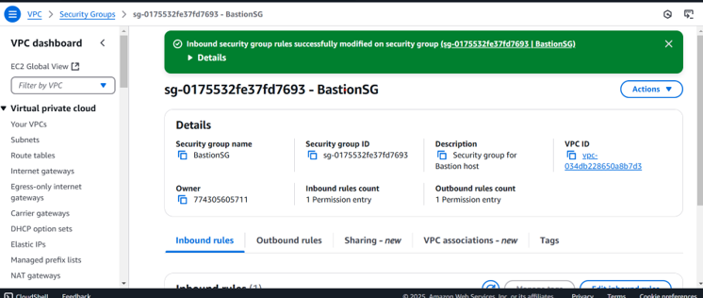

**6.2 Disable Password Authentication**

1. Edit SSH config:

sudo nano /etc/ssh/sshd_config

1. Find and update these lines:

PasswordAuthentication no

PermitRootLogin no

1. Restart SSH service:

sudo systemctl restart sshd

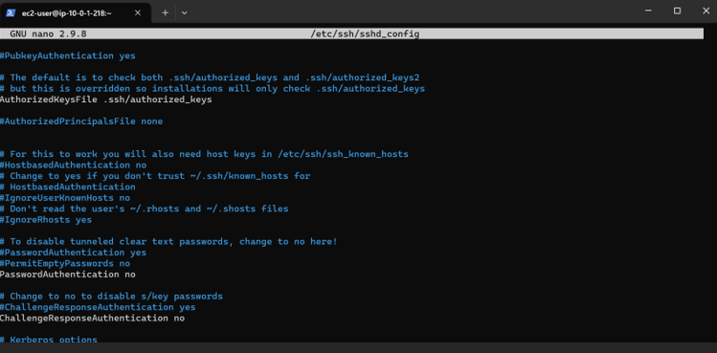

**7. Alternative - Use AWS Systems Manager (SSM) Instead of SSH**

- Attach SSM Managed Policy to EC2 IAM Role (AmazonSSMManagedInstanceCore).

- Enable SSM Agent (Pre-installed on Amazon Linux & Ubuntu).

- Use AWS Systems Manager > Session Manager to connect to instances without SSH

**Outcome:**

* Using a Bastion Host significantly enhances security by acting as a controlled access point to private instances. This setup prevents direct internet exposure, enforces security group rules, and allows monitoring/logging of access.
* For even better security, consider eliminating SSH and using AWS Systems Manager (SSM) Session Manager instead.